*Florida International University*

*School of Computing and Information Sciences*

CIS 4911 - Senior Capstone Project

Software Engineering Focus

Feature Document

User Story #1078

Create Messaging Feature

**Team Member:**

Vladan Lalovic

**Product Owner(s)**:

Masoud Sadjadi

**Mentor(s)**:

Mohsen Taheri

**Instructor**: Masoud Sadjadi

# 

# **User Story – Create Messaging Feature**

## **Description -** 1) As a Pi/Co-Pi/Project Owner, I would like to be able to message Users and receive replies from them as well, so that I can communicate with the users. ‘

## 2) As a User, I would like to receive notifications in my “To-Do’s” that I have received a new message. Also, I would like to be able to reply to the messages I receive.

### **Acceptance Criteria:**

1. Create a page that contains a form for sending a message to users.
2. Project members receive the messages from Project Owners via email and To-Do notifications.
3. Project members can reply to messages received from Project Owners via the messaging form.
4. Project owners receive replies from Project Members via email.

## **Use Case – Create Messaging Feature**

**Use Case ID:** (VIP-1078)

**Details:** The messaging feature should allow Pi/CoPi/Project Owners to message users on the website. The users should receive a to-do notification that they have received a new message, and should be able to reply to the message. The Pi/CoPi/Project Owner who initially sent the message should then receive a to-do notification that the student has replied, and an email with the contents of the reply.

**Actor:** Pi/CoPi/Project Owners/Students

**Pre-conditions:**

1. VIP Server is running.
2. User has navigated to the VIP website and successfully logged in.

**Description:**

1. Use case begins when the User navigates to the teams page (vip-projects).
2. User clicks on an active project, which will show the project details and the project members.
3. User clicks on the “message icon” next to the name of the user they wish to message.
4. User is navigated to the “messaging page”, fills in the “Subject” and “Body” of the message, and presses the “Submit” button.
5. User checks his/her “To-do notifications” and email for confirmation that the message has been sent.

**Post-conditions:**

1. User awaits a reply from the user(s) that have been messaged by waiting for an email and to-do notification to appear.

**Alternative Courses of Action:**

N/A

**Exceptions:**

N/A

**Related Uses Case:**

N/A

**Decision Support:**

**Frequency:** Low. Estimated average of one addition per application execution.

**Criticality:** High. Needed for the site to function correctly.

**Risk:** Low.

**Constraints:**

1. **Usability:** 
   1. No training time required.
   2. User guide should provide more in-depth information.
2. **Reliability:** 
   1. Mean time to Failure – 1% failures for every twenty four hours of operation is acceptable.
   2. Availability – The messaging feature should be available whenever the server is online, and when Gmail is online and working properly as it depends on Gmail.
3. **Performance:** 
   1. To-do notifications and emails should take less than 10 seconds to be available.
4. **Supportability:**
   1. All modern web browsers should be supported.

**Modification History:**

**Owner:** Vladan Lalovic

**Initiation date:** 7/4/2016

**Date last modified:** 7/19/2016

**Use Case Diagram**

C:\Users\Admin\Downloads\UseCaseDiagram1078.png

**Sequence Diagram**

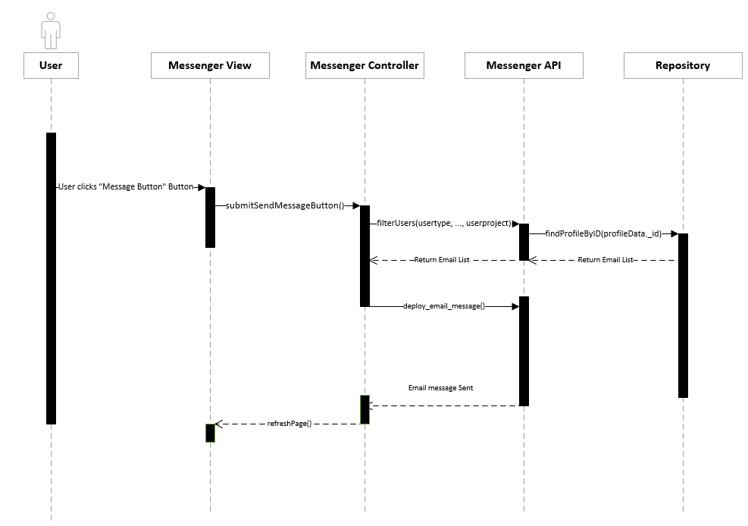

**Class Diagram**

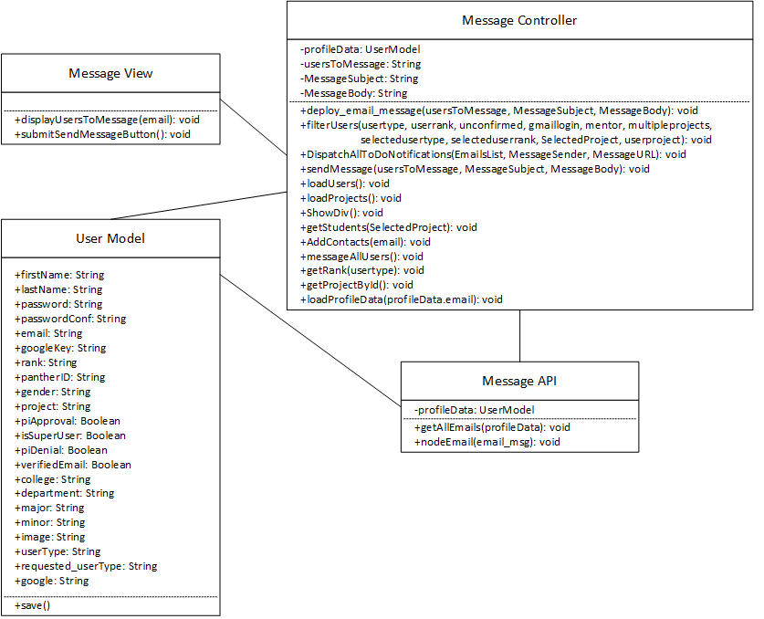

**Unit & Integration Tests:**

**Test Case 1 (Sunny Day)**

**ID: VIP-SD-1078-01**

**Purpose**

* Ensure that emails are sending to the correct email addresses, with the correct subject and body text.

**Precondition**

* The user has permission to access the Messaging page and VIP is running. The user has filled out all of the forms on the messaging page.

**Input**

* The user fills in the receiver addresses, message subject, and message body for the message that is to be sent. Then user presses the “send” button.

**Expected Result**

* The message should be sent to everyone in the contacts list with the correct subject and message body text. A to-do notification should also be added to the users whom will receive the message for them to check their emails and reply to the message ASAP.

**Actual Result**

* The message was sent to everyone with the correct information, and a to-do notification was accurately and successfully created for all of the receiving users.

**Test Case 2 (Rainy Day)**

**ID: VIP-SD-1078-02**

**Purpose**

* Ensure that emails are not being sent with erroneous receiver addresses/subjects/body text by parsing the data inputted into the messaging form.

**Precondition**

* The User is on the messaging page.

**Input**

* User has not filled out a receiver email address, a subject, a message body, or all 3. Then user presses the “send” button.

**Expected Result**

* The email will not be sent due to a lack of the required parameters to send a message.

**Actual Result**

* The server crashed due to poor sanitization of the input values.

## **User Guide – Sending a Message**

**Step 1:** User fills out the “**\*User(s) to Message”, “*Message Subject”,** and **“*Message Body:”** forms

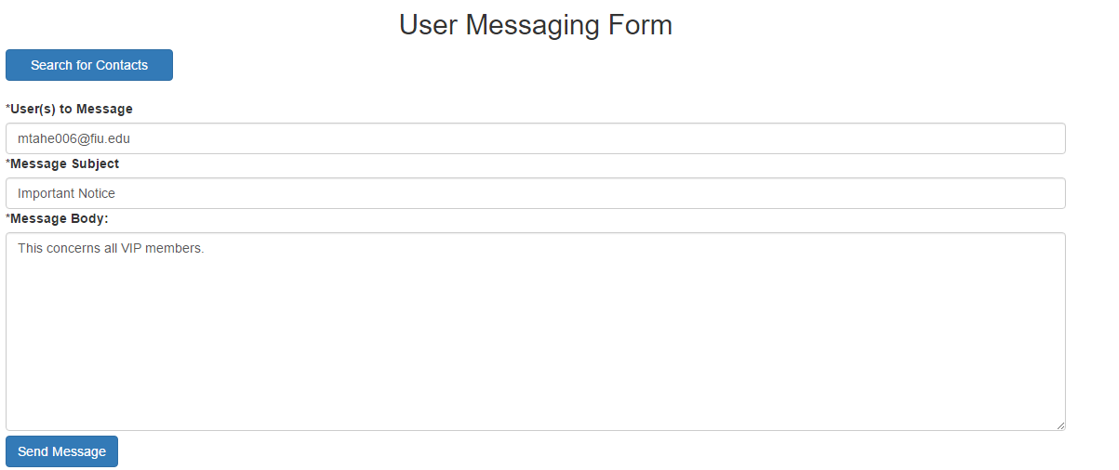

**Step 2:** Developer presses send button to deploy the emails and to-do notifications

